Exploring the World of Normal Distribution

Imagine you're baking a batch of cookies, and you're trying to get them all to be the same size. Despite your best efforts, some come out bigger, others smaller, but most are close to the same size. This natural variation is often what we see in many areas of life--from cookie sizes to people's heights. The mathematical way to describe such natural variations, when most values group around a central point, is called a 'normal distribution.' Let's explore this idea, step by step!

# Step 1: Fundamental Idea

At its core, a normal distribution explains how things in life--like the size of your cookies--tend to cluster around a middle value, with fewer things being very large or very small. Most of your cookies end up about the same size, but you probably get just a few extra-large or extra-small ones. The same pattern is true for other natural traits too, like people's heights, exam scores, or even the time it takes you to commute to work most days.

**Image Description:** Imagine a hill-shaped graph. Cookies with the most common size make up the center or top of the hill, and the very few extra-large or extra-small cookies are like the slopes on the sides of the hill, going down lower.

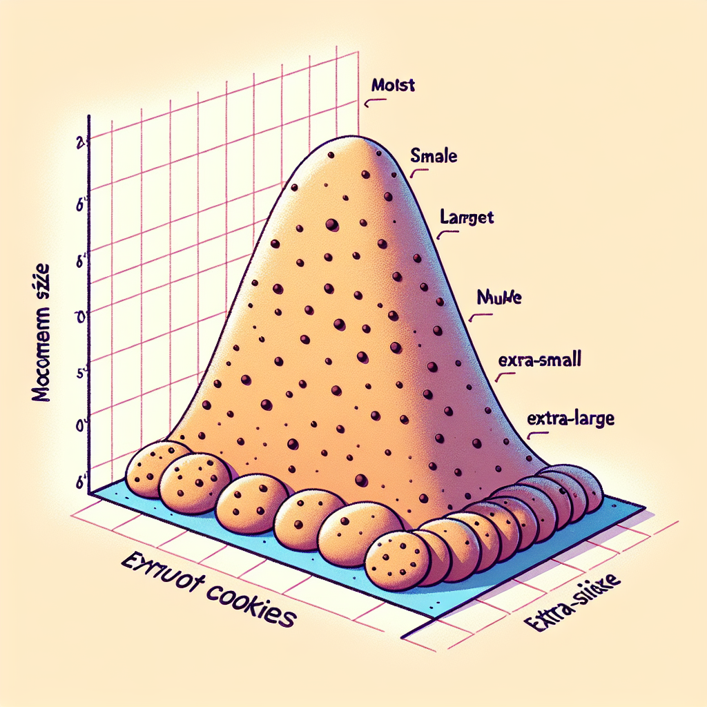

Image Description: Imagine a hill-shaped graph. Cookies with the most common size make up the center or top of the hill, and the very few extra-large or extra-small cookies are like the slopes on the sides of the hill, going down lower.

**Transition:** Now that we understand the basic idea of this 'cookie hill,' let's zoom out and see how this pattern holds for other examples in life, and how we represent it.

# Step 2: Building Upon the Basics

The 'hill shape' really represents something we call a 'bell curve.' Think of it like a balancing act in nature. Most things cluster around an average--the top of the bell--while fewer things swing to the extremes, like super-tall or super-short people. If you line everyone in a room from shortest to tallest, what you'd likely see is that most people are about average height, and only a few are either really tall or really short. This same pattern--the bell curve--represents what's happening.

**Image Description:** Picture a line of people in a room, from shortest to tallest. There are lots of people in the middle around the 'average height,' and just a small number of people on the ends representing either the short or tall extremes. If you drew a curve over their heads, it would look like a bell.

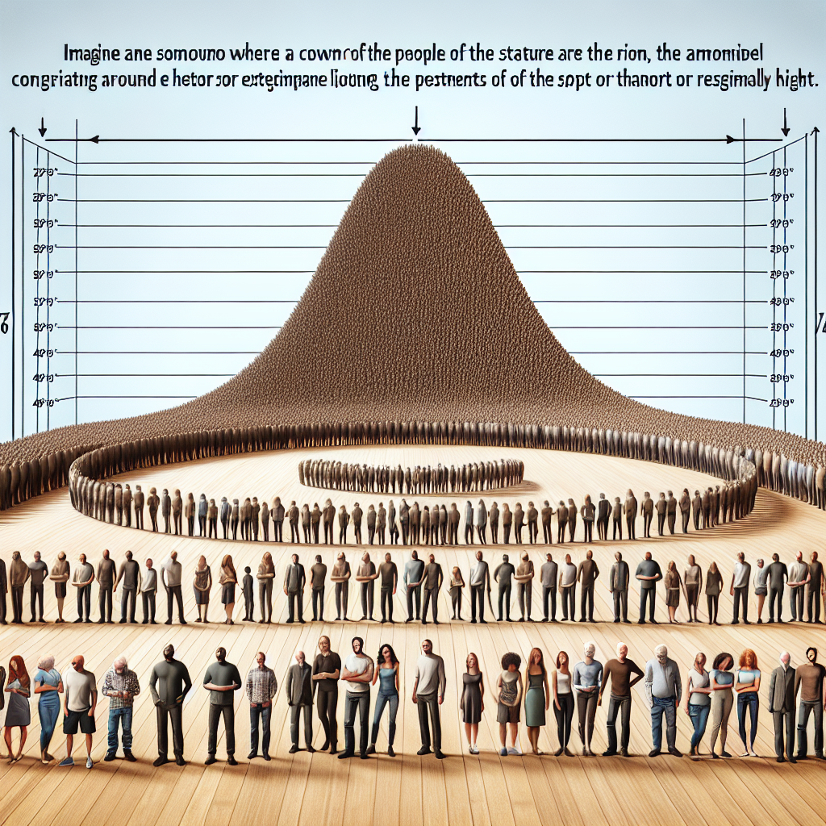

Image Description: Picture a line of people in a room, from shortest to tallest. There are lots of people in the middle around the 'average height,' and just a small number of people on the ends representing either the short or tall extremes. If you drew a curve over their heads, it would look like a bell.

**Transition:** Now let's add one more layer of understanding by talking about how wide or narrow that 'bell' might be, and why that matters.

# Step 3: Spreading Things Out

Sometimes, people's heights--just like cookie sizes--vary a lot. In some groups, the range of heights might be wider, while in others, it could be narrower. This width of the bell curve tells us how much something is spread out, or how 'spread out' the distribution is. If the group includes a lot of variation, the bell is wider and flatter because the values are spread out. If everyone is very similar, the curve is taller and narrower.

**Image Description:** Imagine squeezing or stretching your 'cookie hill' or 'bell curve.' If the cookies are all very close in size, the bell is tall and narrow. If the sizes vary a lot, the bell becomes wider and more spread out.

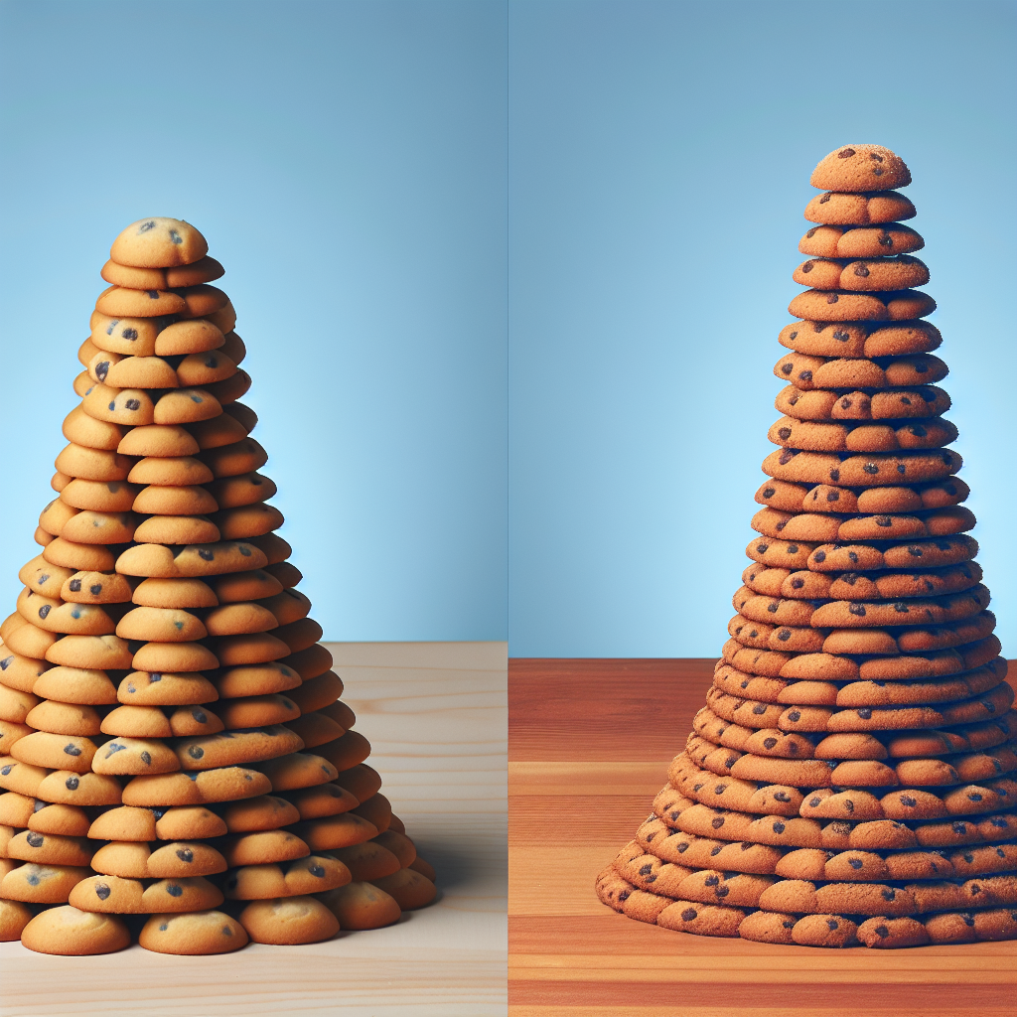

Image Description: Imagine squeezing or stretching your 'cookie hill' or 'bell curve.' If the cookies are all very close in size, the bell is tall and narrow. If the sizes vary a lot, the bell becomes wider and more spread out.

**Transition:** Now that we can see the idea of how tightly or loosely packed the data can be, let's explore why the shape of this curve is so helpful in understanding patterns in the real world.

# Step 4: Why is This Bell-Shaped Curve Important?

The normal distribution curve is a really handy way for scientists, businesses, and planners to understand all sorts of things. For example, teachers might use it to see how students tend to score on a test--most students are probably close to the average score, while only a few get super high (or low) marks. In the workplace, employers might use this curve to predict how many employees will take a certain amount of time to finish a task. It even helps us make predictions about health (like average blood pressure readings) or daily events (like predicting weather patterns). This bell shape holds a lot of power in understanding patterns and making decisions.

**Image Description:** Imagine a teacher looking at a chart of test scores that forms a bell curve: most dots representing students cluster in the middle, while only a few dots are at the top or bottom representing rare high or low scores.



Image Description: Imagine a teacher looking at a chart of test scores that forms a bell curve: most dots representing students cluster in the middle, while only a few dots are at the top or bottom representing rare high or low scores.

**Transition:** Let's take this final step and see how this idea applies in saving time and making accurate decisions.

# Step 5: Predicting the Future with the Bell Curve

One of the coolest things about the normal distribution is how it lets us make predictions! Since we know that most things fall near the center of the curve (like most cookies turn out about average-sized), we can estimate how much something might change. For example, based on past patterns, companies can predict how often breakdowns will happen in a machine or how likely it is to get rainy weather based on historical data. It's like taking a peek into the future by understanding past patterns!

**Image Description:** Imagine a factory manager looking at past records of machine breakdowns. The data forms a bell curve, where most breakdowns happen after a predictable amount of time, allowing the manager to estimate when the next one might occur.



Image Description: Imagine a factory manager looking at past records of machine breakdowns. The data forms a bell curve, where most breakdowns happen after a predictable amount of time, allowing the manager to estimate when the next one might occur.

**Transition:** Now that we've explored all aspects of the normal distribution, let's wrap up what we learned.

# Conclusion

The normal distribution, symbolized by the bell curve, is everywhere around us. It's a natural pattern showing us that most things tend to cluster around an average value, and fewer things happen at the extremes. From cookies to people's heights, test scores, and more, the bell curve helps us understand the world's patterns. Knowing about this distribution helps scientists, teachers, and planners make better predictions and decisions based on past trends. With this practical tool, we can see clearer patterns in life's everyday variations and use them in meaningful ways!